If you don’t have time, you can just read the red text.
All questions and answers can found in the link below
https://apcentral.collegeboard.org/courses/ap-computer-science-a/exam/past-exam-questions
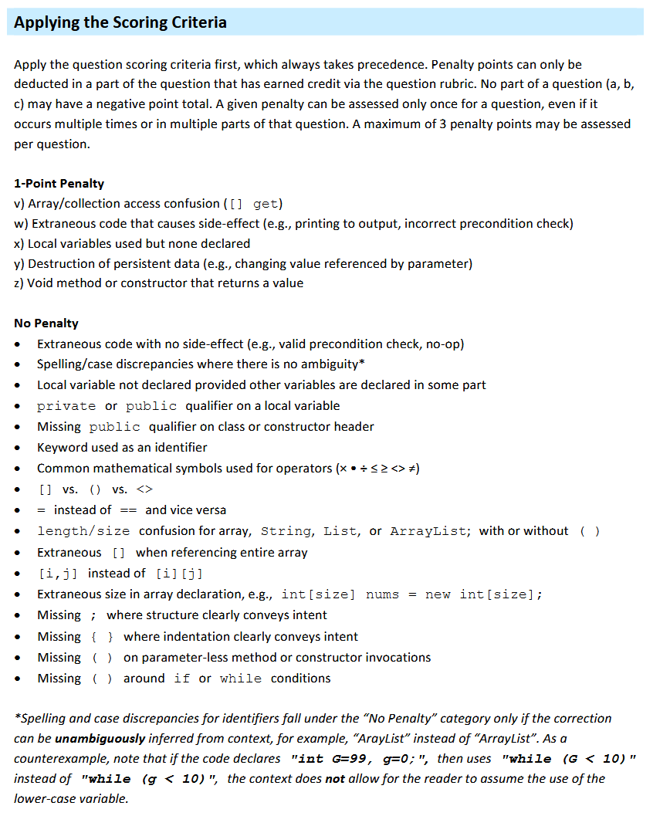
2024: Free-Response Questions
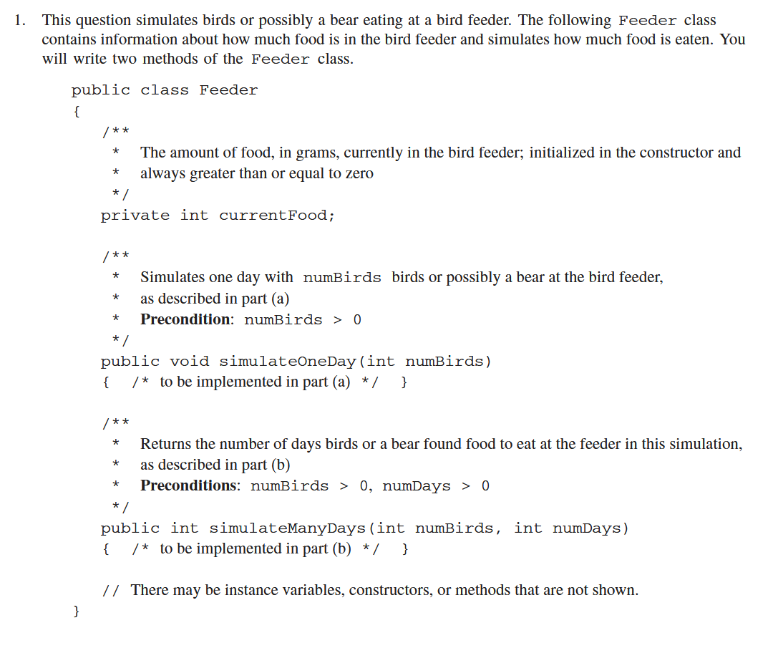
A Feeder class for simulation( 1 var, 2 function )
public class Feeder
private int currentFood
public void simulateOneDay(int numBirds)
public int simulateManyDays(int numBirds, int numDays)
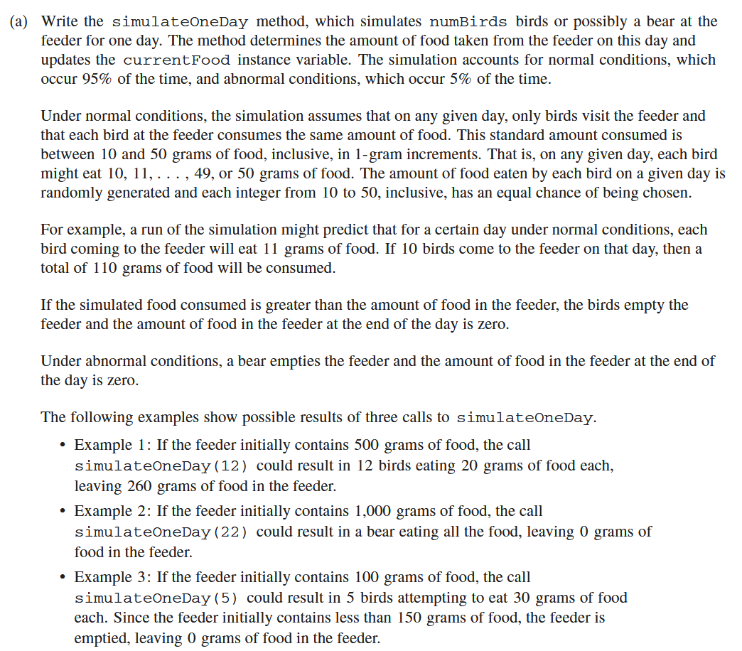
Requirements
write function public void simulateOneDay(int numBirds)
no return only calculate and change private int currentFood
95% birds eats, 5% bear eats
each bird eats (10, 50] determine by each day
bear eat all

Points
example doesn't show the bear part and possibility, but need to implement
Math.random() < 0.05 test if bear come
(int) (Math.random() * 41 + 10) get each consum
[0, 1) * 41 = [0, 41)
[0, 41) + 10 = [10, 51)
(int)[10, 51) = only integer, range from [10, 50]

Logic
given birds
if 95%
consum = random(10, 50]
totalConsum = consum * birds
currentFood = currentFood – totalConsum
if currentFood < 0 then currentFood = 0
else
currentFood = 0

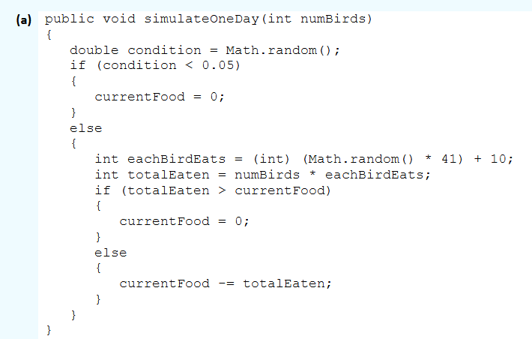

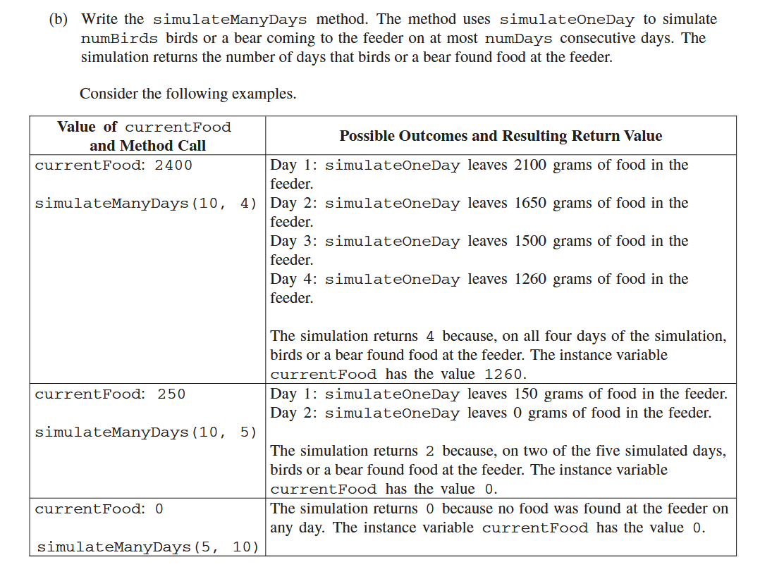
Requirements
write function public int simulateManyDays(int numBirds, int numDays)
return int for which day has no food
numBirds is fixed for every day

Points
for loop i is count from 0, so day 2 mean i == 3

Logic
given numBirds, numDays
for day in numDays times
if currentFood == 0 return day
simulateOneDay(numBirds)
return numDays
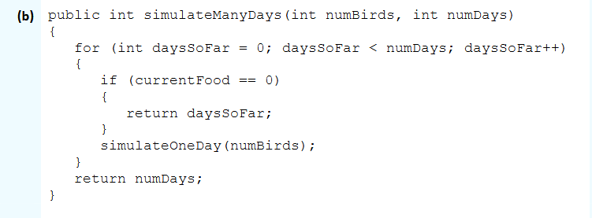

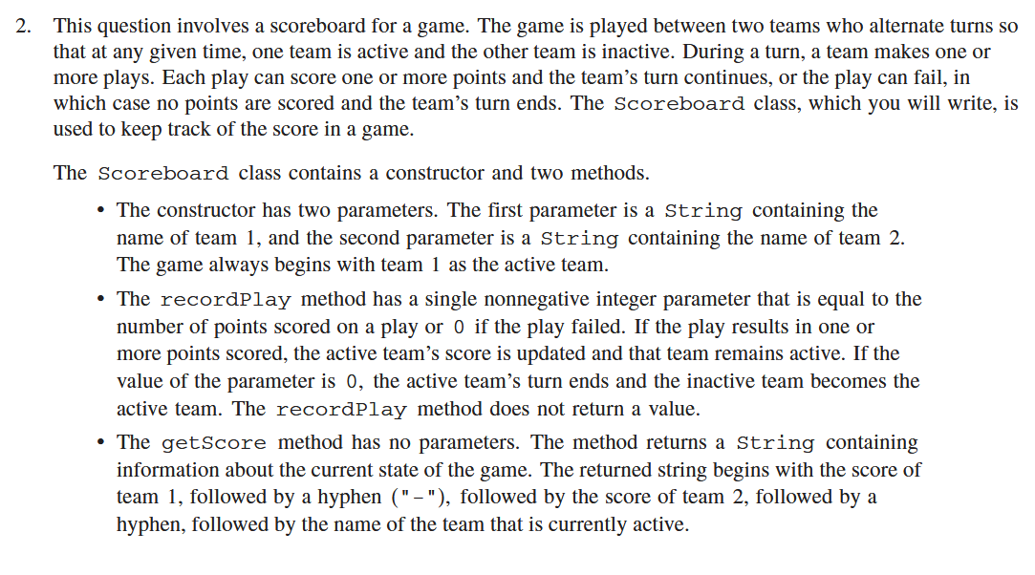
Requirements
create class Scoreboard has 3 methods simulate the game
public class Scoreboard
public Scoreboard(String team1, String team2)
public void recordPlay(int score)
public String getScore()
recordPlay need add score until the play fained(score == 0) and change the activeTeam
getScore return String like “3-11-Yunu”
default team1 active

Points
need to store
String team1Name
String team2Name
int team1Score
int team2Score
boolean isTeam1Active || int whoseTurn

Logic
constructor Scoreboard
store names and set isTeam1Active

public void recordPlay(int score)
if score == 0
isTeam1Active = !isTeam1Active
else
add score to active team

public String getScore()
str = team1Score + ‘-’ + team2Score + ‘-’
str += if isTeam1Active then team1Name else team2Name

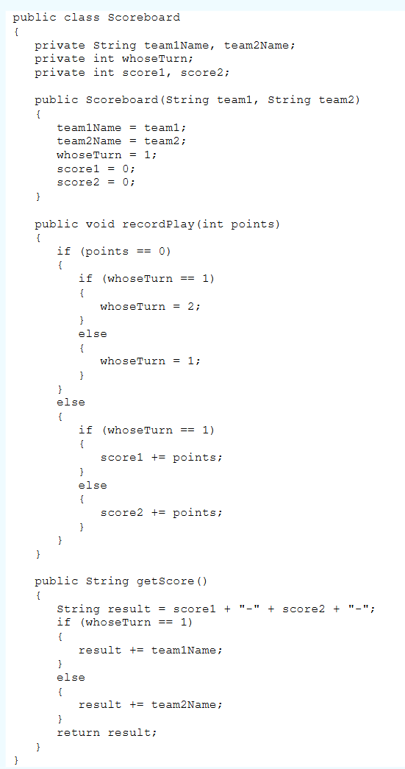
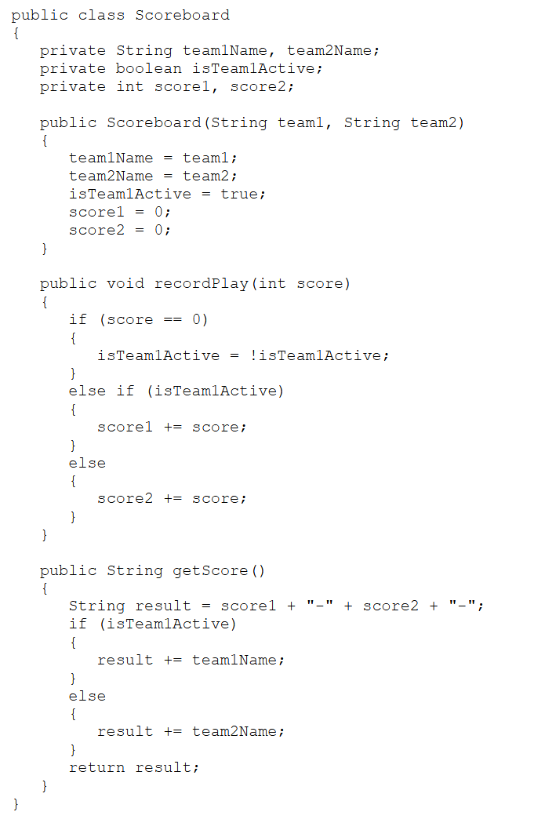
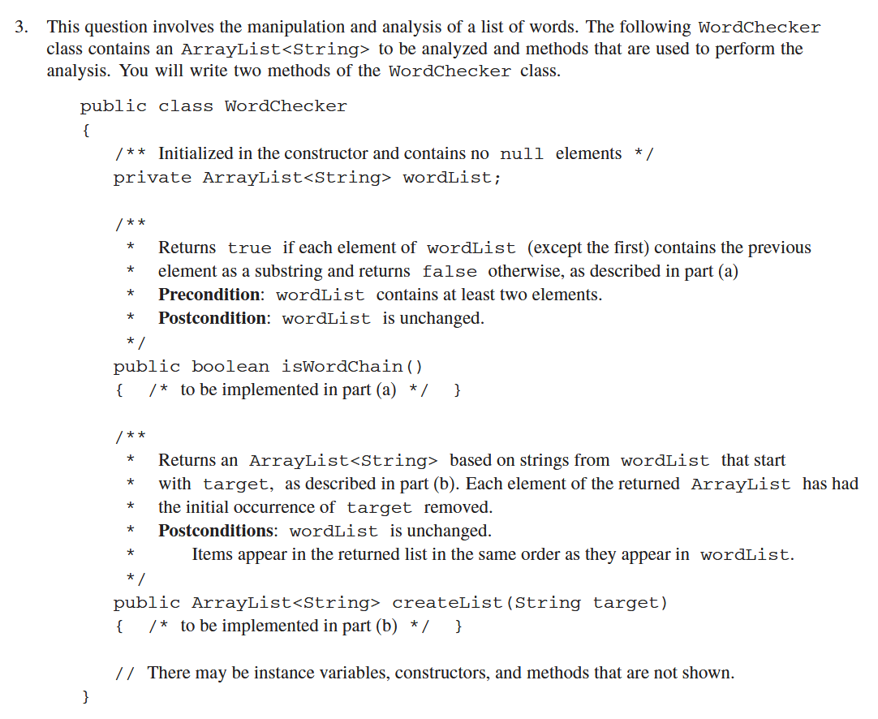

Requirements
use wordList to check word
public class WordChecker
private ArrayList<String> wordList
public boolean isWordChain(String target)
public ArrayList<String> createList(String target)

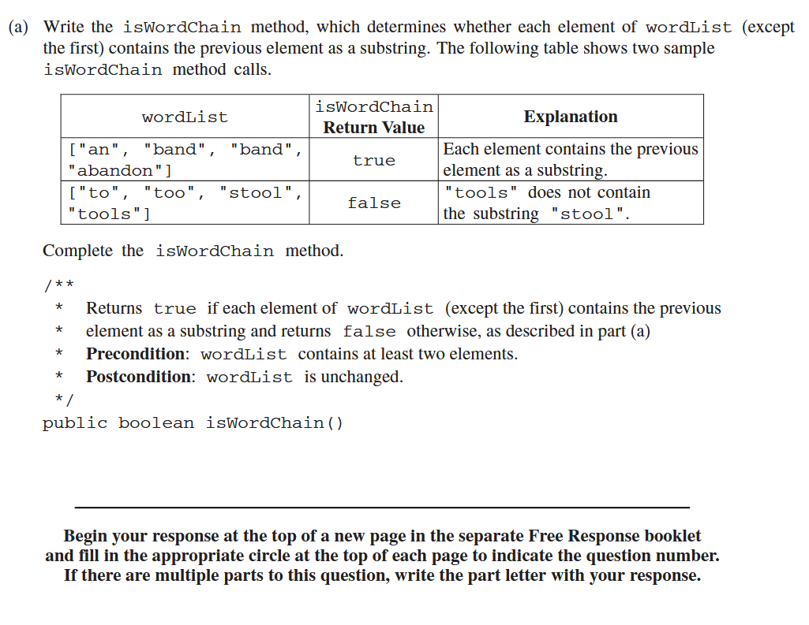
Requirements
write public boolean isWordChain()
isWordChain return is every word of wordList [i] has [i – 1] as substring

Points
String method indexOf return -1 if string not found

Logic
for i in range of wordList.size(), i start with 1
currentString = [i]
previousString = [i – 1]
if currentString not have previousString
return false
return true
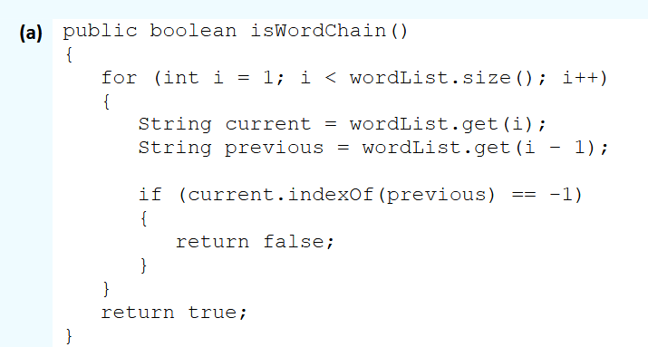
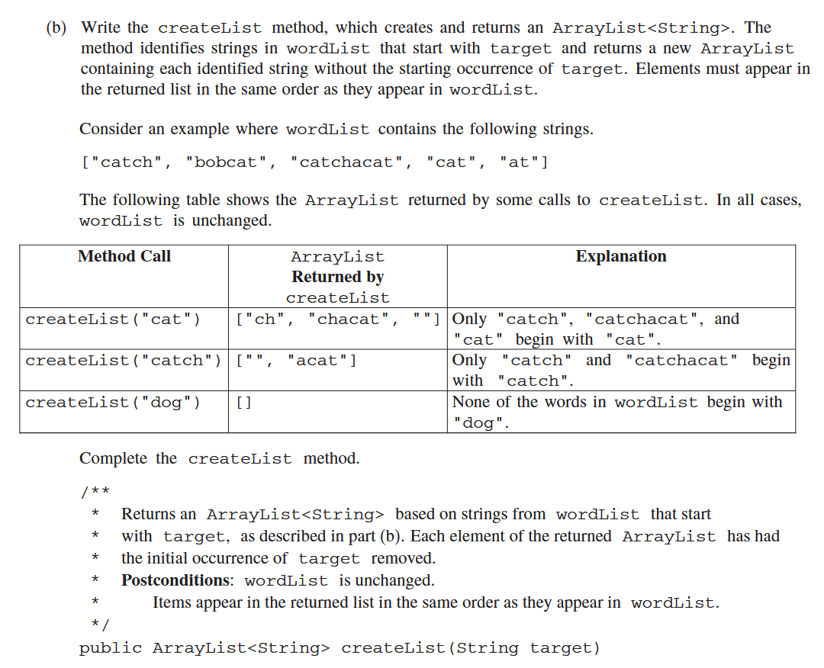

Requirements
write function public ArrayList<String> createList(String target)
createList return a new ArrayList which only contain word start with target, but each item remove the target part

Points
String indexOf, substring

Logic
given target
create newList
for each item in wordList
if item has target as start
item remove first target.length
add to newList
return newList

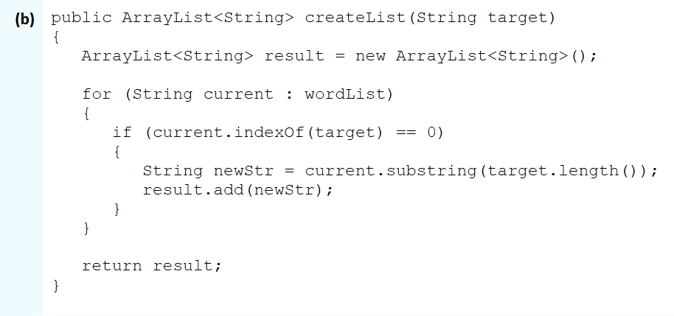

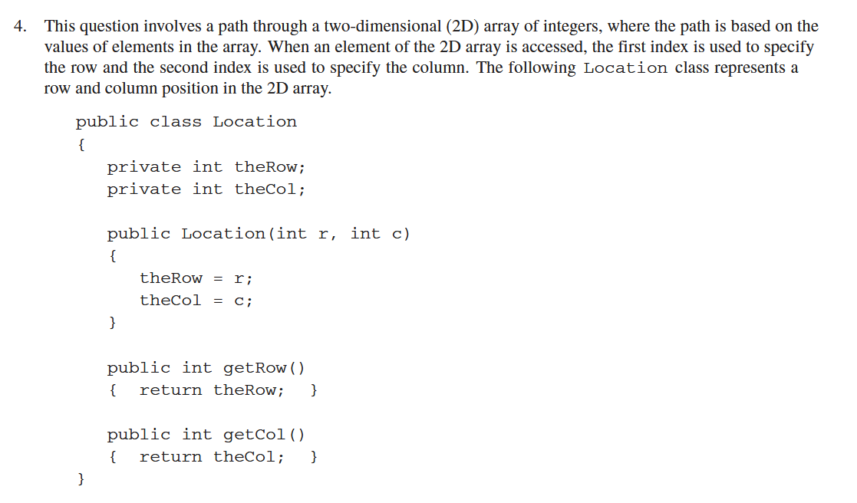
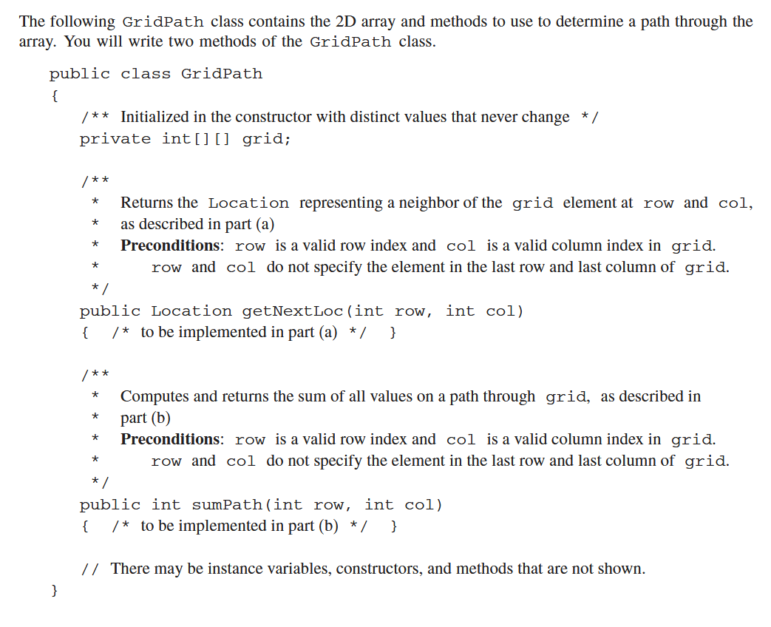

Requirements
Find path in grid(2d array) by it’s contain value
class Location(to show the position)
private int theRow
private int theCol
public Location(int r, int c)
public int getRow()
public int getCol()
class GridPath
private int[][] grid
public Location getNextLoc(int row, int col)
public int sumPath(int row, int col)

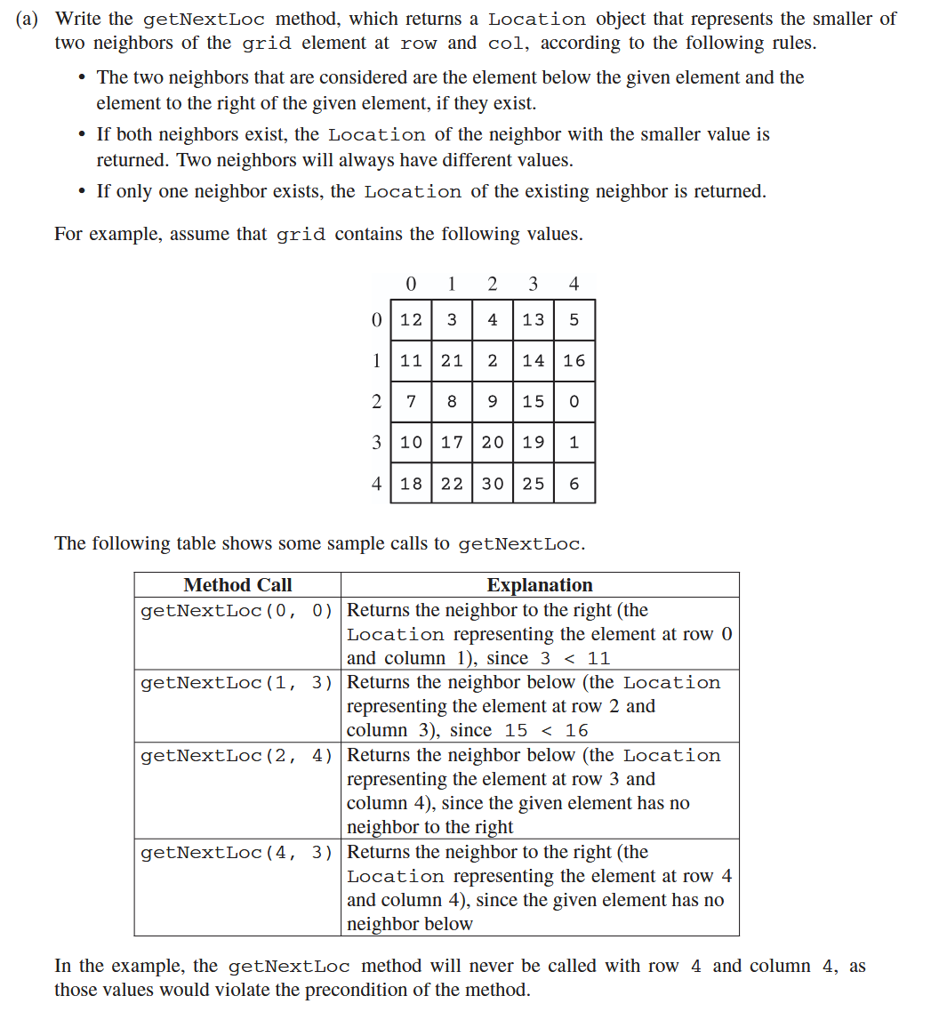
Requirements
write public Location getNextLoc(int row, int col)
check row + 1 and col + 1, and find the smaller one and return the position using Location

Points
be careful about the index out bound error
if it’s only has one neighbor, return the only neighbor
the last item in grid will has no neighbor but it’s not defined so ignored

Logic
given row, col
if col is last element return [row + 1][col]
else if row is last element return [row][col + 1]
else if [row + 1][col] < [row][col + 1] return …
else …
all return need to use Location Class
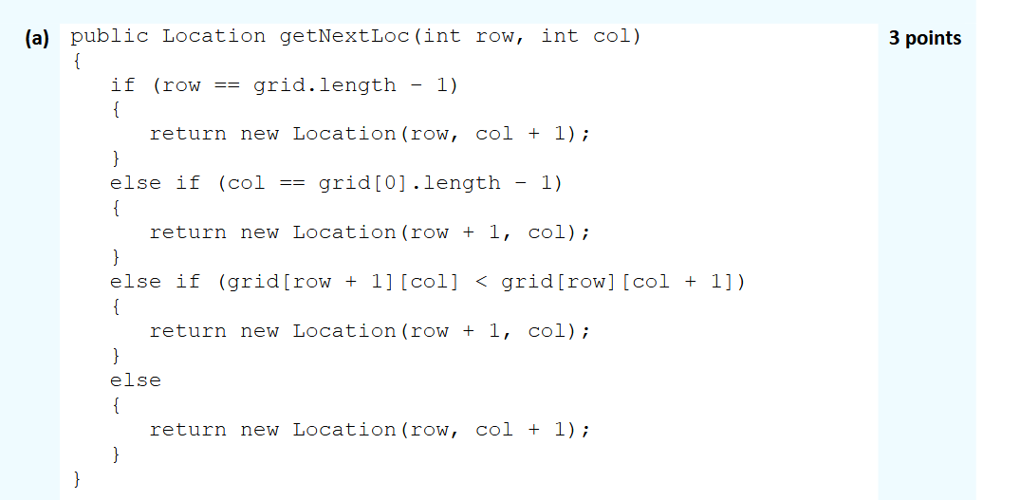

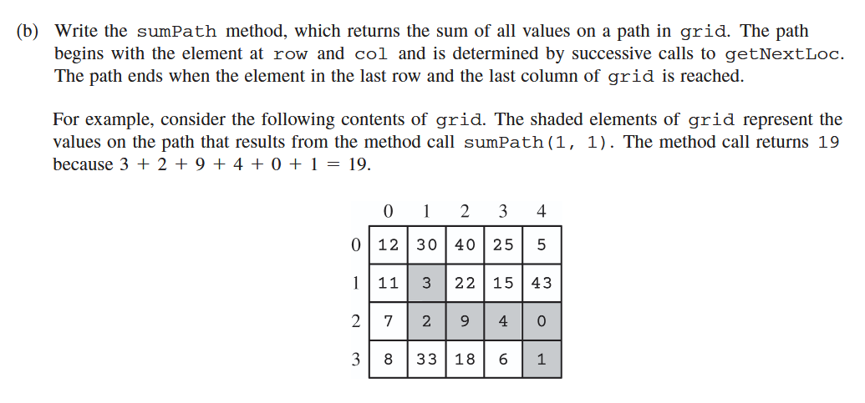
Requirements
write function public int sumPath(int row, int col)
start in row, col and follow the path, sum all the value until reach the right corner

Points
getNextLoc return Location object, use getRow and getCol

Logic
given row, col
currentRow = row
currentCol = col
sum = 0
while row, col is not the last
sum += grid[col, row]
loc = getNextLoc(currentRow, currentCol)
currentRow = loc.getRow()
currentCol = loc.getCol()
return sum
